**The Contributions of Hydroelectric Dam Methane Emissions to Climate Change in the Amazon Basin**

Natalie Kadonaga

HSA 10-5 The Economics of Oil and Energy

April 7, 2016

**I. The State of Hydroelectric Power in the Amazon Basin**

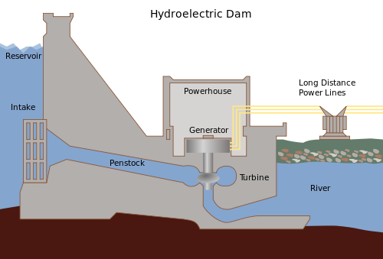The current climate change crisis has many countries looking for renewable alternatives that can replace traditional thermoelectric energy generation with increasing domestic electricity use. To meet this demand, countries with high levels of precipitation such as those in the Amazon Basin plan to take advantage of their abundant water resources through hydroelectric dam projects. Peru, Ecuador, Bolivia, and Colombia plan for 150 new dams over the next 20 years, a 300 percent increase from their 48 current dams.[1] Brazil plans for 43 new large dams (producing at least 30 megawatts of electricity), 10 of which are to be completed by 2022[2] to increase the country’s energy capacity by more than 50 percent.[3] While hydroelectric dams appear beneficial and cost-effective because they have a renewable fuel source, many studies over the past 30 years have shown that the process of flooding large areas of vegetation to construct these dams have significant greenhouse gas emissions. These emissions, which are especially prevalent in tropical regions such as the Amazon, are comparable to those of fossil fuels. In this paper, we will discuss the consequences of hydroelectric power by explaining its current technology and its greenhouse gas emissions in order to demonstrate that hydroelectric power is not a viable solution for replacing fossil fuels.

Figure : A diagram of a typical hydroelectric dam. In this case, the water would flow from left to right.

**II. The Mechanics of Hydroelectric Power Generation and Dam Construction**

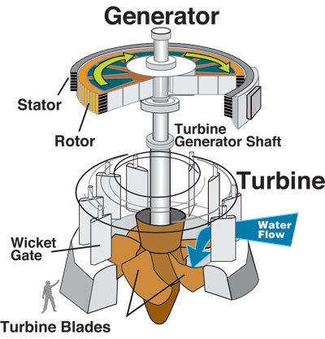An understanding of the greenhouse gas emissions of hydroelectric dams requires a prerequisite understanding of how the conversion of water and altitude into power translates to current methods of dam construction. Dams convert the mechanical energy of water going from high elevation to low elevation into electricity. To do this, the dam’s intake releases water from the reservoir and the water goes through a penstock to go through turbine propellers (figure 1). As shown by figure 2, these propellers are connected to the turbine generator shaft, which rotate as the water flows through the propellers. Mounted around the shaft above the turbine are electromagnets, which are loops of wire around magnetic laminations. These units, called field poles, rotate while the stator, made of conductors, remains stationary. When the field poles move past the conductors, electricity flows. This electricity can then be transported across transmission lines for residential, commercial, or industrial use.[4]

Figure : A diagram of a hydroelectric generator courtesy of U.S. Army Corps of Engineers.

The greater the amount of water and drop in elevation, the greater the rate of water flow and energy generated.[5] The construction of a dam increases the elevation gradient by raising the elevation of the river’s water upstream and forming a reservoir. The formation of a reservoir floods a large area of vegetation and soil between the old water level and the new water level.[6] In countries like Brazil with less drops in elevation, reservoirs are larger and shallower to accommodate a greater amount of water and therefore a larger energy output. As a result, these reservoirs flood a greater area, drowning acres of vegetation.

One example of this phenomenon is the Balbina Dam, a hydroelectric dam on the Uatumã River in Brazil, which flooded 773,193 acres of rainforest, creating Balbina Lake, one of the world’s largest hydroelectric reservoirs.[7] The creation of the reservoir not only killed off acres of rainforest, but it also transformed the decomposing biomass into carbon dioxide and methane, two contributors to climate change. The dams in Brazil planned for completion by 2022 will flood 193,681 acres of land. To understand the potential for environmental harm, we require an explanation of how flooded vegetation turns into greenhouse gases.

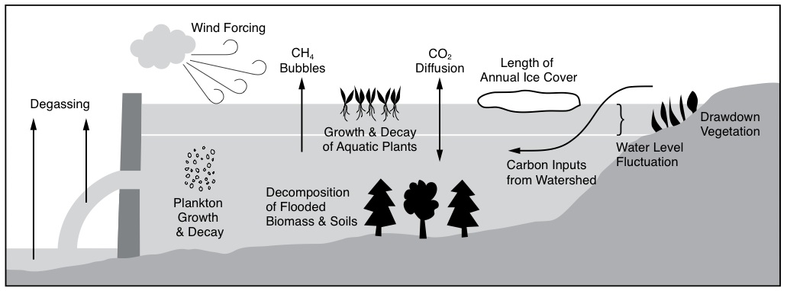

Figure : A schematic of factors that contribute to reservoir greenhouse gas emissions. We will focus on the causes of methane (CH4) emissions.

**III. The Production of Greenhouse Gases by Reservoirs and the Potency of Methane**

At the bottom of reservoirs, sediment and bacteria collect in the oxygen-poor environment. As part of the carbon cycle, bacteria decomposes the dead biomass and releases methane gas (CH4) to the surface (figure 3). In deep reservoirs, some methane oxidizes to carbon dioxide gas (CO2) on the long travel to the surface. However, in shallow reservoirs, like Balbina and other reservoirs in the tropics, there is little oxygen. Therefore, in these anaerobic environments, the biomass decomposes into methane instead.[8] Studies have also shown methane emissions from turbines, intakes, and rivers downstream.[9]

While carbon dioxide and methane are both greenhouse gases, methane is more potent in its effect on climate change. The Intergovernmental Panel on Climate Change (IPCC) explains this potency through a measurement of global warming potential (GWP). The GWP compares the amount of energy absorbed by the emissions of one ton of the measured greenhouse gas to the emissions of one ton of carbon dioxide.[10] The IPCC’s 2013 Anthropogenic and Natural Radiative Forcing reports the GWP of methane over 20 years to be 84-86 and over 100 years to be 28-34. The uncertainty is due to the indirect effects of methane, which include methane as a precursor to ozone, which is also a greenhouse gas. With methane’s GWP100 around 30, this means that methane absorbs 30 times more energy than carbon dioxide over the course of 100 years.[11]

We will use the units of pounds of carbon dioxide equivalent per kilowatt-hour (pounds CO2e/kWh) as the emission factor to compare the harmful effects on climate change between reservoir emissions, which is mostly methane, and fossil fuel generation emission, which is mostly carbon dioxide. It is important that we account for the greater potency of methane over that of carbon dioxide because it shows the full effect of the reservoir’s methane emissions on global warming. By comparing these different fuel sources by the final impact on the environment, we can grasp the quantitative environmental externalities of hydroelectric dams that make them an unsuitable fossil fuel replacement.

**IV. Emission Factors for Tropical Hydroelectric Reservoirs and Fossil Fuels**

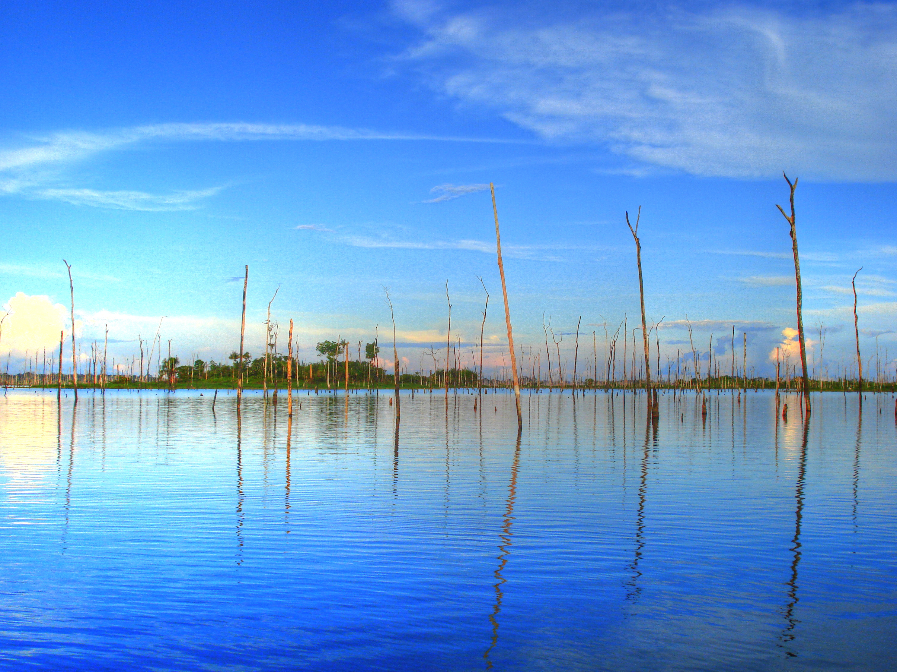In order to demonstrate that the greenhouse gas emissions of tropical hydroelectric reservoirs are comparable to those of fossil fuels, the emission factor will be calculated from measurements of carbon dioxide and methane emissions data provided online. For the tropical reservoirs, we will calculate the emission factors for the previously mentioned 250 megawatt Balbina Dam, along with data from 8370 megawatt Tucuruí Dam in Brazil, 30 megawatt Curuá-Unã Dam in Brazil, 116 megawatt Petit-Saut Dam in French Guiana, and group of 9 unspecified Brazilian reservoirs ranging in capacity from 216 to 12,600 megawatts. For the fossil fuels, we will calculate emission factors for coal, natural gas, and oil, which are fuels commonly used in electricity generation.

Figure : The decomposing rainforest in Balbina Lake.

Balbina’s emissions are given as 26.20 106 t CO2e/TWh, so this must be converted to pounds CO2e/kWh. There are 2,000 pounds in a ton, so there are 2,000 * 1,000,000 pounds in 1 million tons. There are 1,000,000,000 kWh in a TWh. Therefore, to convert 106 t CO2e/TWh to pounds CO2e/kWh, we multiply 26.20 by (2,000 * 1,000,000 / 1,000,000,000) to get **52.4 pounds CO2e/kWh**. We perform a similar calculation for Tucuruí to convert 0.58 106 t CO2e/TWh to **1.16 pounds CO2e/kWh**.

Curuá-Unã’s emissions are given as 0.15 106 t CO2e and its generation over one year is given as 0.19 TWh, so to calculate its 106 t CO2e/TWh we divide 0.15 by 0.19 to get 0.789. We multiply 0.789 by (2,000 * 1,000,000 / 1,000,000,000) to get **1.58 pounds CO2e/kWh**.[12]

Petit-Saut’s emissions are given as 455 grams CO2e/kWh, so converting grams to pounds is 455 / 453.592 to get **1.00 pounds CO2e/kWh**. We perform a similar calculation for the average emissions of a group of 9 Brazilian reservoirs to convert 160 grams CO2e/kWh to **0.35 pounds CO2e/kWh.** We will also include the reservoirs from this group with the highest and lowest emissions, with 6 grams CO2e/kWh and 2,100 grams CO2e/kWh converting to **0.013 pounds CO2e/kWh** and **4.6** **pounds CO2e/kWh.**

After calculating the emission factors for a several tropical reservoirs, the next step is to calculate the emission factors for fossil fuel electricity generation. EIA provides the emissions of fossil fuels for bituminous coal, subbituminous coal, lignite coal, natural gas, distillate oil, and residual oil. The EIA gives these emissions in units of pounds CO2e/kWh, so conversion calculations are not necessary.

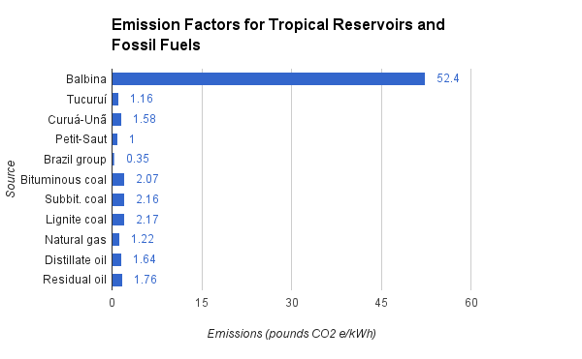At last, the emissions in pounds CO2e/kWh can be consolidated into the bar chart in figure 5.

Figure : A chart representing the calculated emissions per generation for several hydroelectric dams and fossil fuels.

An examination of our table shows that the emissions for Balbina and Curuá-Unã are actually worse than those of natural gas, while Tucuruí and Petit-Saut are nearly as bad. The group of 9 reservoirs have a large range of emissions, with the worst offender substantially surpassing all fossil fuels. The worst case is Balbina, which is explained by the vast area it flooded and its small amount of generation. This case is clearly an outlier, but its existence should serve as a fair warning to more carefully evaluate the environmental impact of the hydroelectric dams planned for construction in the Amazon over the next decade.

**V. Conclusion**

Although using hydroelectric power is attractive for its cheap and renewable fuel source and its independence from fossil fuels, consideration of tropical reservoir greenhouse gas emissions comparable with those of fossil fuels indicates that hydroelectric is not the solution for expanding electricity generation in the Amazon Basin. If Amazonian countries Brazil, Peru, Ecuador, Bolivia, and Colombia follow through with the planned constructions of dams over the next decade, human contribution to greenhouse gas emissions may increase despite dams replacing fossil fuel plants. [1561]

1. Finer, Matt, and Clinton N Jenkins. “Proliferation of Hydroelectric Dams in the Andean Amazon and Implications for Andes-Amazon Connectivity.” PLoS ONE 7 (4)2012. http://journals.plos.org/plosone/article?id=10.1371/journal.pone.0035126#pone.0035126-Barrow1.
2. Fearnside, Philip M. “Amazon Dams and Waterways: Brazil’s Tapajós Basin Plans.” Ambio 44 (5)2015. http://link.springer.com/article/10.1007/s13280-015-0642-z.
3. Forero, Juan. “Brazil Building More Dams across Amazon.” The Washington Post, February 92013. https://www.washingtonpost.com/world/the_americas/brazil-building-more-dams-across-amazon/2013/02/09/f23a63ca-6fba-11e2-b35a-0ee56f0518d2_story.html.
4. "Hydroelectric Power: How It Works." Hydroelectric Power: How It Works, USGS Water-Science School. August 7, 2015. Accessed March 03, 2016. http://water.usgs.gov/edu/hyhowworks.html.
5. "Hydropower Explained." Hydropower - Energy Explained, Your Guide To Understanding Energy - Energy Information Administration. May 12, 2015. Accessed March 03, 2016.
6. "How Hydropower Works." How Hydropower Works. Accessed March 3, 2016. http://www.wvic.com/content/how_hydropower_works.cfm.
7. Gaworecki, Mike. “Tapajós and Other Amazon Dams Not Sustainable Development Say Reports.” Mongabay. 2015. Tapajós and other Amazon dams not sustainable development say reports.
8. "Dirty Hydro: Dams and Greenhouse Gas Emissions." Dirtyhydro_factsheet_lorez.pdf. November 2008. Accessed March 3, 2016. https://www.internationalrivers.org/files/attached-files/dirtyhydro_factsheet_lorez.pdf.
9. "Frequently Asked Questions: Greenhouse Gas Emissions from Dams." Greenhouse Gas Emissions from Dams FAQ | International Rivers. May 1, 2007. Accessed March 03, 2016. https://www.internationalrivers.org/resources/greenhouse-gas-emissions-from-dams-faq-4064.
10. "Understanding Global Warming Potentials." Understanding Global Warming Potentials | Climate Change | US EPA. February 23, 2016. Accessed March 03, 2016. http://www3.epa.gov/climatechange/ghgemissions/gwps.html.
11. Myhre, G., D. Shindell, F.-M. Bréon, W. Collins, J. Fuglestvedt, J. Huang, D. Koch, J.-F. Lamarque, D. Lee, B. Mendoza, T. Nakajima, A. Robock, G. Stephens, T. Takemura and H. Zhang, 2013: Anthropogenic and Natural Radiative Forcing. In: Climate Change 2013: The Physical Science Basis. Contribution of Working Group I to the Fifth Assessment Report of the Intergovernmental Panel on Climate Change [Stocker, T.F., D. Qin, G.-K. Plattner, M. Tignor, S.K. Allen, J. Boschung, A. Nauels, Y. Xia, V. Bex and P.M. Midgley (eds.)]. Cambridge University Press, Cambridge, United Kingdom and New York, NY, USA.
12. Fearnside, Philip M. "Hydroelectric Dams in the Brazilian Amazon as Sources of ‘Greenhouse’ Gases." Envir. Conserv. Environmental Conservation 22, no. 01 (January 1995): 7. ResearchGate.